# Connect to your VM with SSH

SSH (Secure Shell) is a secure, encrypted connection to your virtual machine. Free SSH clients are available for every platform. Download one like putty for your computer if necessary (Mac OS X and Linux users should already have one installed) and set up a connection using your VM hostname and login information.

For Windows:

* Download putty from: <http://www.chiark.greenend.org.uk/~sgtatham/putty/download.html>
* Run the putty program.
* Put the **FQDN for your server** you saved in the **host name** box of putty.
* Put **22** in the **Port** text box
* Select the **SSH** radio button.
* Under Saved Sessions type a name for this configuration setup.
* Click Save.
* (If you open putty again later, you can click on the saved session name in the list and putty will populate all the settings for you that you designated.)
* Click **Open**.
* When the Putty Security alert pops up click **Yes**.
* When it asks, type in your LAMP **server Admin name** and press enter.
* Type in the LAMP **server Admin password** and press enter. (!!! Note as you type nothing will appear. This is a security feature. What you type is there, you just cannot see it.)
* You should now be successfully logged in to your server using SSH as shown below.
* You should see a window with a command line that looks something like this:

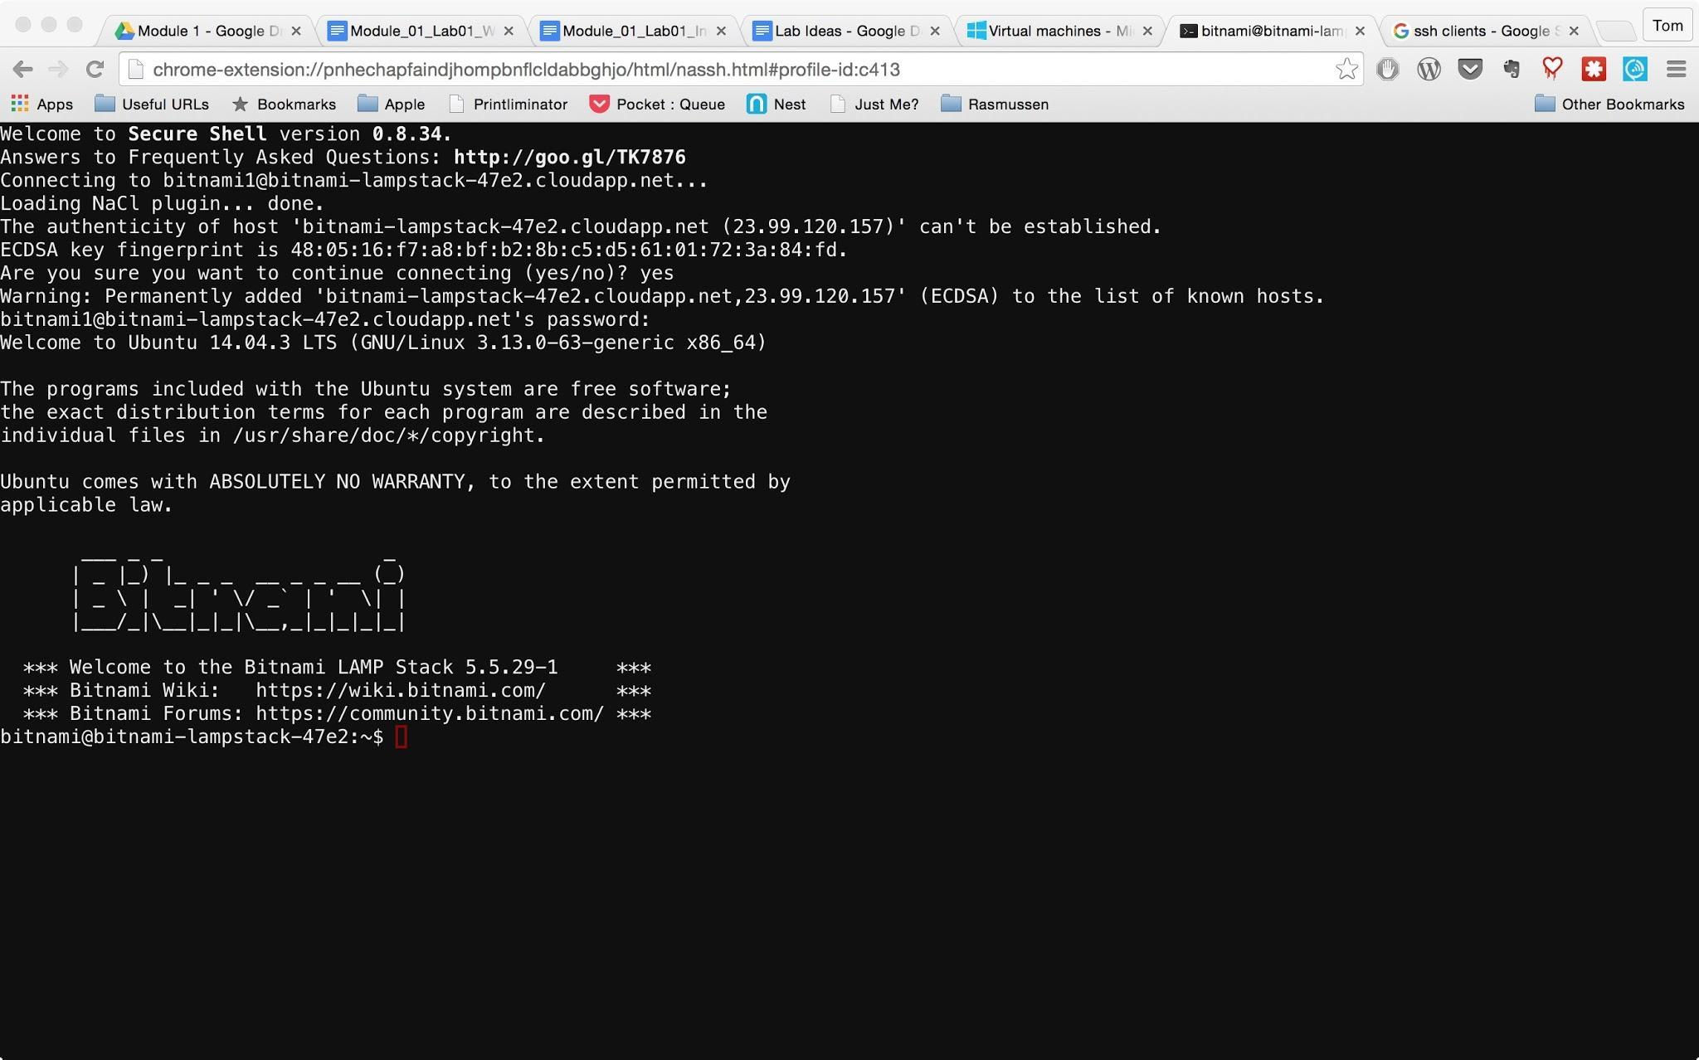

You've successfully logged in to the server.

Type **exit** at the command prompt and **press enter**.

You are now logged out of the Putty server connection.